DECLARATION BY STUDENT

I certify that this assignment is my own work and is in my own words. All sources have been acknowledged and the content has not been previously submitted for assessment to Asia e University or elsewhere. I also confirm that I have kept a copy of this assignment.

Date: 12/13/2025 Signature: Dafa Radhitya Hanif

ANSWER SHEET

STUDENT ID | C30109240088
STUDENT NAME | Dafa Radhitya Hanif
IC / PASSPORT NUMBER | E0160983
SUBJECT CODE | CHC401
SUBJECT NAME | Human Computer Interaction
PROGRAMME | BICT (HONS)
DATE OF SUBMISSION | 12/13/2025
LEARNING LOCATION | Online/CBN

INSTRUCTION TO CANDIDATES

- Fill in the details required on this page clearly and legibly
- Begin your answer for each question on a new page
- Write the question number at the top of each answer page
- Please rename the answer script by subject code and student matric number (e.g: ALI BIN ABU MPU3222 C10101240001)
- Begin writing your answers on this page (Font: Arial or Times New Roman, Size: 11 or 12, Lines Spacing 1.5)

YOU MAY START ANSWERING FROM THIS PAGE

EduLearn App: E-Learning Application
Table Of Content

1. Introduction
1.1 Background
1.2 Problem Statement
1.3 Objectives
1.4 Scope of the Project

2. User Analysis
2.1 Target Users
2.2 User Content
2.3 User Problems and Need
2.4 User Requirements
2.5 Problem Summary

3. Requirement Analysis
3.1 Architecture Overview
3.2 System Flow
3.3 Interface Design Summary
3.4 Data Design
3.5 Materials & Quiz Structure
3.6 Navigational Design

4. Prototype
4.1 Login Interface
4.2 Home Interface
4.3 Learning Materials Interface
4.4 Quiz Interface
4.5 Progress Interface

5 Summary & Conclusion
6 Future Improvements

7. Appendix
A. User Survey Questionnaire
B. User Survey Responses
C. System Usability Scale (SUS) Questionnaire
D. SUS Responses

1 Introduction:

The rapid development of technology in the education sector has encouraged the creation of digital learning tools that are more interactive and accessible for students. EduLearn is a simple Windows Forms–based e-learning application designed to support students in understanding basic networking concepts through structured learning materials and quizzes.
This application provides four main features: user login, material viewing, quiz assessment, and progress tracking. Each feature is designed using Human–Computer Interaction (HCI) principles to ensure clarity, consistency, and ease of use. EduLearn aims to help students learn independently while still receiving immediate feedback on their performance, making it suitable for beginner-level learners in networking or IT-related courses.

1.1 Background

Digital learning has become an essential part of modern education, especially for beginner-level learners who need accessible and simplified learning tools. Many students entering IT-related fields often struggle with understanding foundational concepts because traditional learning materials are too technical, text-heavy, or scattered across different sources. As a result, beginners require a platform that presents information in a structured, guided, and easy-to-follow format.

EduLearn was developed to address this need by providing a desktop-based learning environment that combines clear learning materials, interactive quizzes, and real-time progress tracking. By integrating these features into a single application, EduLearn aims to support independent learning while helping students build confidence as they develop their foundational knowledge in computer networking.

1.2 Problem Statement

Despite the availability of online resources and textbooks, many beginner learners still face significant difficulties in understanding core networking concepts. Existing platforms are often designed for intermediate or advanced users, making them overwhelming for students who are just starting out. Additionally, beginners lack tools that provide instant feedback and clear indicators of learning progress.

EduLearn seeks to solve these issues by offering a simple, structured, and focused learning experience. The application reduces unnecessary complexity, provides direct feedback through quizzes, and visually displays progress so that learners can monitor their improvement. This ensures that users receive the guidance and clarity they need while learning at their own pace.
1.3 Objective
The primary objectives of the EduLearn application are:

1. To provide beginner-friendly learning materials for basic computer networking.
EduLearn aims to simplify foundational networking concepts so that first-year students or users with minimal technical background can learn without feeling overwhelmed.

2. To create an interactive and structured learning experience.
The app organizes content into clearly separated sections—Materials, Quiz, and Progress—allowing users to follow a guided learning flow.

3. To reinforce learning through quizzes and instant feedback.
Each quiz submission provides immediate correctness feedback, helping users evaluate their understanding and correct misconceptions.

4. To help learners track their improvement over time.
EduLearn includes a progress tracking system that visualizes quiz performance, enabling users to monitor how much they’ve learned and what areas need improvement.

5. To design a simple, clean, and user-friendly interface following HCI principles.
The app prioritizes clarity, consistency, and accessibility so that beginners can navigate the system easily.

1.4 Scope of the Project

The project scope outlines the functional boundaries of EduLearn:

Included in Scope
- User Login System:
Basic username input that personalizes the learning experience.
- Learning Materials Module:
Displays selected topics about basic networking, accessible through a dropdown selection.
- Quiz Module:
Contains multiple-choice questions related to the materials, including answer validation and scoring logic.
- Progress Tracking Module:
Shows last quiz score, total correct answers, total attempted questions, and a progress bar visualization.
- Navigation between Forms:
Home → Materials → Quiz → Progress → Exit application.
- User Interface Design:
Simple visual design with background images, clear color coding, and readable fonts.

Out of Scope

To keep the project focused for academic requirements, several advanced features are intentionally excluded:

- No database or cloud-based user storage
- No user authentication (password system)
- No advanced analytics or leaderboard
- No multimedia content (videos/animations)
- No mobile/web version—Windows Forms only
- Only basic quiz logic (no timed exams or randomization)

The scope ensures that EduLearn remains achievable within the course timeline while still meeting essential HCI design principles.

2. Requirement Analysis

2.1 Target Users

EduLearn is designed for beginner-level learners who are starting to explore fundamental computer networking concepts. The application mainly supports individuals who require a simple, structured, and easy-to-understand learning tool without overwhelming complexity.
The primary target users include:
- Beginner IT students who are taking their first networking-related course.
- Vocational/high school students who need simplified digital learning materials.
- Individuals with minimal technical background who need step-by-step guidance.
- Self-learners who want a lightweight app for independent study.
2.2 Usage Content

Usage Context
EduLearn is intended for learning environments where users need quick access to structured materials and self-assessment tools. The context ensures that the app remains simple, accessible, and responsive for a wide range of learning scenarios.

Usage environment includes:
- Classroom/lab sessions: Students follow materials while the lecturer demonstrates concepts.
- Home/self-study: Learners study independently using a personal laptop.
- Short learning sessions: Users typically interact with the app for 5–15 minutes per module.
- Windows-based devices: Since the application is built using Windows Forms, usage occurs primarily on laptops/PCs.

User actions within context:
- Logging in to personalize the session.
- Reading learning materials sequentially.
- Switching topics through content selection.
- Taking quizzes to test understanding.
- Tracking progress through score and percentage indicators.

2.3 User Problems and Need

Before using EduLearn, users commonly face several learning barriers:

User Problems
- Difficulty understanding networking concepts due to technical complexity.
- Lack of a centralized and structured learning tool combining materials + quizzes.
- Overwhelmed by long or unorganized learning resources (for examples in websites, PDFs, textbooks).
- No clear way to track learning progress or measure improvement.
- Limited access to applications that provide instant feedback.
- Need a simple interface that avoids confusion.

User Needs
- A clean, guided environment to study networking fundamentals.
- Easy navigation between materials and quizzes.
- Immediate scoring and feedback.
- Progress tracking to visualize improvement over time.
- Lightweight application that does not require technical expertise to operate.

EduLearn is designed to meet these needs by combining structured materials, quiz assessments, and progress tracking within a simple, user-friendly interface.

2.4 User Requirements

User requirements define what the application must provide to support learning activities.

- Functional Requirements (FR)

The system must be able to:
- Authenticate basic user identity through a simple login screen.
- Display learning materials and allow selection between multiple topics.
- Present quizzes based on the selected questions.
- Allow users to select answers using radio buttons.
- Calculate quiz scores automatically based on correct answers.
- Store last quiz score and total progress in the application session.
- Display progress including percentage, total score, and number of questions answered.
- Provide reset functionality to clear progress when needed.
- Navigate between pages (Home, Materials, Quiz, Progress).
- Exit the application safely using an End Process button.

b. Non-Functional Requirements (NFR)

These define system qualities and constraints:
- Usability: The interface must be easy for beginners to navigate.
- Readability: Content should use clear fonts and structured layout.
- Responsiveness: Switching materials or quiz items must feel quick.
- Performance: The app should load instantly and respond without delay.
- Reliability: Score and progress must always update accurately.
- Consistency: Colours, fonts, and layout should follow the same style.
- Error prevention: Prevent submission without selecting an answer.
- Availability: The app should run offline without external dependencies.
Together, these requirements ensure the application is stable, simple, and accessible for beginners.

2.5 Problem Summary

A quick summary of the core learning challenges and how EduLearn addresses them:

- Users lack simple, structured materials
Solution: EduLearn provides guided topics
- Users need a way to test their understanding
Solution: Built-in quizzes
- Users cannot see their learning progress
Solution: Progress tracking system
- Users feel overwhelmed by heavy/complex resources
Solution: Beginner-friendly UI and explanations
- Users need feedback
Solution: Instant scoring system

EduLearn acts as a compact, beginner-oriented digital learning tool that solves these core user challenges.

3. Overall Application Design

3.1 Architecture Overview

EduLearn adopts a modular, form-based architecture, where each core function of the application is separated into its own Windows Form. This ensures a clean structure, easier maintenance, and flexibility when adding new features in the future.
Main architectural components:

- Login Module
Handles username input and session initialization.
- Home Module
Acts as the central navigation hub linking all other parts of the system.
- Materials Module
Displays structured learning content using topic selection (ComboBox) and detailed text (RichTextBox).
- Quiz Module
Loads quiz questions dynamically from a dictionary structure and validates answers.
- Progress Module
Tracks scores, number of questions answered, and visual progress through a percentage bar.
- Session Management (UserSession / AppData)
Stores active username, last quiz score, total scores, and total number of questions answered.

3.2 System Flow

The system flow describes how users move through the application. EduLearn follows a simple and intuitive linear flow:
- Login → Home
User enters a name to start the session, stored in UserSession.
- Home → Materials
User selects a topic and reads through structured content.
- Home → Quiz
User attempts questions presented via dynamic loading.
- Home → Progress
User views their learning performance and progress.
- Home → End Process
User exits the application when finished.

3.3 Interface Design Summary

EduLearn’s interface is built using a simple, minimalistic layout to accommodate beginner-level learners. The application uses:

- Soft blue theme for general actions
- Blue buttons blend with the theme and used for important confirmation actions (Login, Submit)
- Red buttons for critical actions (Logout, Back)
- Consistent fonts and alignment across all forms
- Background image layer for improved aesthetics

Form Highlights

Login Form
- Username input
- Welcome label
- Green “Login” button
- Background image for warmth and aesthetic value

Home Form
- Welcome message (personalized)
- Large navigation buttons: Materials, Quiz, Progress
- Logout and End Process options

Materials Form
- Left: ComboBox to select a topic
- Right: RichTextBox showing detailed content
- Back button

Quiz Form
- ComboBox to choose a question
- Four radio buttons for answer options
- Submit Answer button
- Back button

Progress Form
- Username display
- Last quiz score
- Total correct answers
- Total questions attempted
- Progress bar showing learning percentage
- Reset Progress button
- Back button

All forms follow the same spacing, margin, colour consistency, and visual hierarchy.

3.4 Data Design

Session Storage
EduLearn uses two small static classes to maintain data during the application runtime:

UserSession.cs
Stores username:
public static class UserSession
{
public static string Username { get; set; }
}

AppData.cs
Stores quiz-related information:
public static class AppData
{
public static int TotalScore { get; set; }
public static int TotalQuestions { get; set; }
public static int LastQuizScore { get; set; }
}
These values reset when the application closes or if the user selects “Reset Progress.”

3.5 Materials & Quiz Structure

Materials Dictionary
Topics and explanations are stored in a dictionary:

Dictionary<string, string> materials = new Dictionary<string, string>()
{
{ "Topic 1", "Full explanation..." },
{ "Topic 2", "Full explanation..." },
};

Quiz Dictionary

Questions are stored as a tuple so each item contains:
- Question text
- Array of 4 options
- Index of the correct answer
Dictionary<string, (string Question, string[] Options, int Correct)> quizData
This allows easy expansion without modifying the UI.

3.6 Navigational Design

EduLearn uses a forward-open, backward-close pattern:
- Moving forward = Open new form (Show)
- Moving backward = Close current form
This prevents form stacking and ensures memory efficiency.

Example:
From Materials → Back → Home
Means: Materials closes, Home reopens.

4 Prototype

4.1 Login Interface

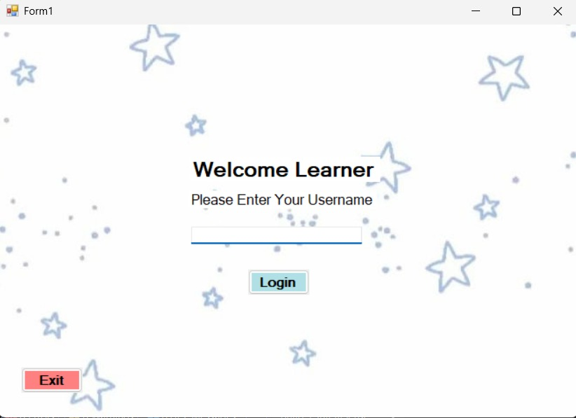

The login page is the first interface displayed when the EduLearn application is launched. In this screen, the user is required to enter a username before accessing the main features of the application.

The login interface includes:
- “Welcome Learner” label as a greeting message.
- Instruction text “Please Enter Your Username” to guide the user.
- A username textbox for input.
- A “Login” button (green-themed) that navigates to the Home page.
- An “Exit” button (red-themed) to close the application.
- A star-pattern background image, giving the page a light, friendly, and approachable visual design suitable for beginner-level learners.

The login page is intentionally designed to be simple, minimal, and easy to understand to ensure a smooth onboarding experience for first-time users.

4.2 Home Interface

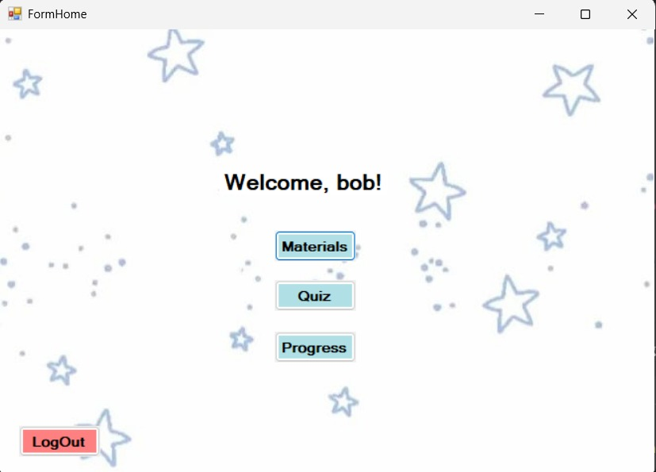

The Home page is the main navigation interface displayed after the user successfully logs into the EduLearn application. This screen acts as the central hub where users can choose which module they want to access based on their learning needs.

The Home interface includes:
- A personalized greeting label (“Welcome, username!”) that displays the name entered during login.
- A “Materials” button that navigates the user to the Learning Materials page.
- A “Quiz” button that directs the user to the interactive quiz module.
- A “Progress” button that opens the progress tracking page.
- A “Logout” button (red-themed) that returns the user to the Login page.
- A star-pattern background image, maintaining visual consistency with the Login screen and creating a friendly, beginner-oriented learning environment.

The Home page is designed to be straightforward and minimalist, ensuring users can easily understand the navigation and access each feature without confusion.

4.3 Learning Materials Interface

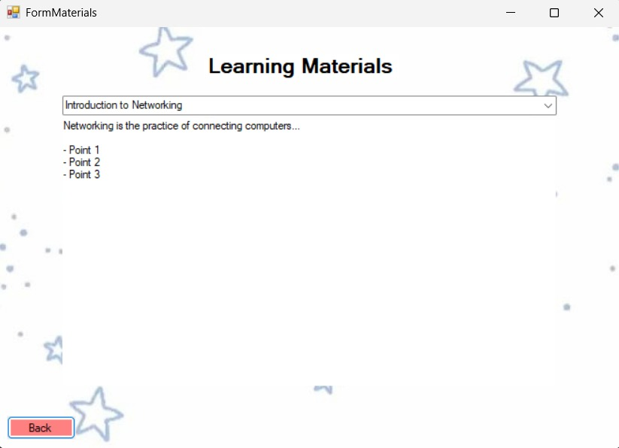

The Learning Materials page displays structured educational content related to basic computer networking. This page allows users to browse through multiple topics efficiently and read each material in a clean, readable layout.

The Learning Materials interface includes:
- A dropdown selection menu (ComboBox) containing the available learning topics such as Introduction to Networking, OSI Model Overview, and IP Addressing Basics.
- A RichTextBox that displays detailed learning content based on the selected topic.
- A “Back” button (red-themed) that returns the user to the Home page.
- A star-themed background, following the visual identity of the application.

The use of a dropdown selection provides an efficient and scalable way to manage multiple materials without overwhelming the interface. This layout ensures that users can focus on learning without unnecessary distractions.

4.4 Quiz Interface

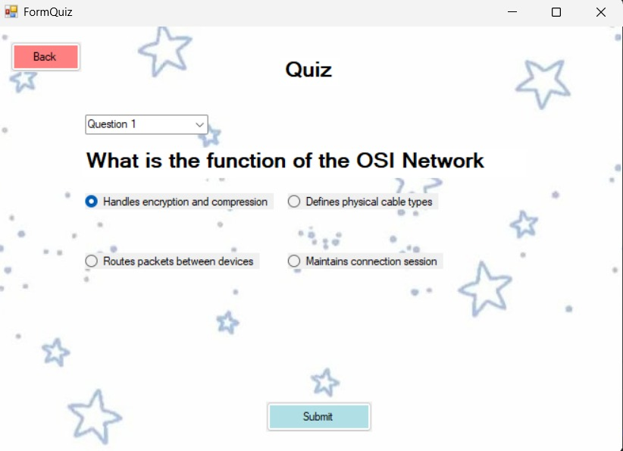

The Quiz page serves as the interactive learning module where users can test their understanding of networking concepts covered in the materials. Each question is presented clearly, with answer options arranged for easy selection.

The Quiz interface includes:
- A dropdown menu allowing users to switch between available quiz questions.
- A prominently displayed question label, formatted for readability.
- Four radio button answer choices, representing options A, B, C, and D.
- A “Submit” button (green-themed) that checks the user’s selected answer and displays feedback.
- A “Back” button (red-themed) that returns the user to the Home page.
- A star-pattern background, keeping the look consistent with other screens.

The page is purposely kept uncluttered to help beginners focus solely on answering the questions. When the user submits an answer, the system evaluates it and updates the stored progress, encouraging continuous learning.

4.5 Progress Interface

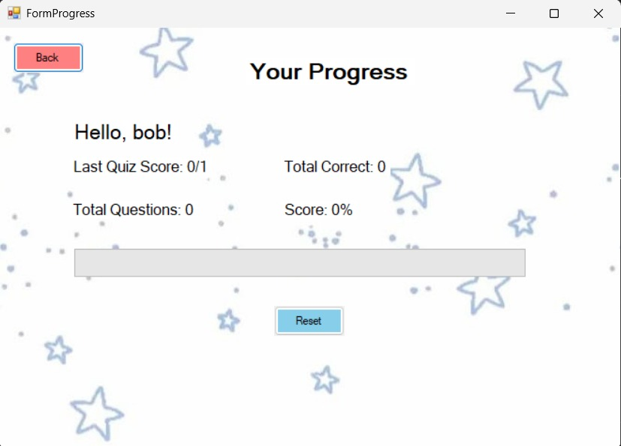

The Progress page displays a summary of the user’s performance throughout their learning journey. This page provides motivation and visibility into how much the user has learned so far.

The Progress interface includes:
- A greeting label (“Hello, username!”) showing the logged-in user’s name.
- A “Last Quiz Score” label, showing the most recent score out of the total available points.
- A “Total Correct” label, showing the user’s cumulative number of correct answers.
- A “Total Questions” label, indicating the total number of questions attempted.
- A “Score (%)” label, showing the user’s learning progress in percentage format.
- A progress bar, visualizing the user's performance through a simple percentage bar.
- A “Reset” button (blue-themed) that clears all recorded progress data.
- A “Back” button (red-themed) that navigates the user back to the Home page.
- The same star-pattern background, maintaining the application’s visual identity.

The Progress page provides a clean and informative overview of the user’s development. It helps learners see their achievements and understand which areas may need improvement. The reset feature also allows users to restart their learning journey from zero if needed.

5 Summary & Conclusion

The development of the EduLearn application demonstrates how a simple and structured e-learning tool can support beginner learners in understanding fundamental computer networking topics. Throughout the project, the application successfully integrates three essential features—Materials, Quiz, and Progress Tracking—into a user-friendly interface designed using Windows Forms.

The Materials section allows learners to browse multiple structured lessons through a clean selection menu. The Quiz module transforms learning into an interactive experience by presenting dynamic questions and evaluating answers in real time. Meanwhile, the Progress page provides meaningful feedback that visualizes the learner’s improvement through cumulative scores and progress percentage, reinforcing continuous learning.

From a technical standpoint, the project applies fundamental programming practices, such as event-driven design, dictionary-based data storage, shared session handling, and multi-form navigation. Each feature was implemented with simplicity, clarity, and maintainability in mind, ensuring that the application remains stable and easy to expand.

Overall, the EduLearn application meets the core requirements of the project: providing an accessible environment for beginners to learn networking concepts, offering interactive assessment, and giving users insight into their learning progress. While the current version already fulfils its intended purpose, the system can be further enhanced in the future with features such as databases, multi-topic quizzes, user accounts, cloud sync, and more advanced UI/UX improvements.

6 Future Improvements

While the current version of EduLearn successfully meets its functional requirements, there are several opportunities to enhance the application further. These improvements would increase usability, scalability, and effectiveness as a long-term learning platform.

1. Database Integration
Currently, user progress and quiz data are stored in memory only for the active session. Integrating a database (e.g., SQLite, MySQL, or Firebase) would allow persistent user accounts, saved progress, and multi-session tracking.

2. Expanded Learning Modules
The current material collection focuses on fundamental networking concepts. Future updates could include:
- More detailed topics (TCP/IP, subnetting, protocols)
- Multimedia content (images, diagrams, videos)
- Practical lab simulations

3. Improved Quiz System
The quiz currently uses a simple dictionary structure. Enhancements could include:
- Randomized question order
- Multiple quizzes per topic
- Timed assessments
- Explanation pages for incorrect answers

4. Enhanced User Interface / UX
The application uses basic WinForms components. UI could be modernized by:
- Adding animations or a cleaner layout
- Using custom styles and themes
- Improving responsiveness on various screen sizes

5. User Authentication Features
A more robust login system could be added, such as:
- Password support
- User registration
- Admin panel for managing materials and quizzes

6. Exportable Progress Reports
Progress could be exported as a PDF report, enabling students to document learning outcomes or submit results to instructors.

7. Conversion to Mobile or Web App
To reach more learners, the system could later be redeveloped using:
- Flutter or React Native (mobile)
- HTML/CSS/JavaScript + backend (web)

These improvements would allow EduLearn to grow into a more complete and professional learning tool.

7 Appendix

Appendix A User Survey Questionnaire

Edu Learn – Learning Needs & E-Learning Usage Survey

Section 1: Demographics
- Age: ______
- Gender:
☐ Male ☐ Female ☐ Prefer not to say
- Field of Study / Major: ___________________
- Year/Semester of Study: ___________________

Section 2: Learning Behaviour & E-Learning Usage
- How often do you use e-learning or digital learning tools?
☐ Daily ☐ Weekly ☐ Monthly ☐ Rarely ☐ Never
- Which learning platforms have you used before?
☐ Moodle ☐ Google Classroom ☐ Microsoft Teams
☐ YouTube ☐ Canvas ☐ Other: ________
- What type of learning resource do you use the most?
☐ Text modules ☐ Videos ☐ Quizzes ☐ Simulations
☐ Other: ________

Section 3: User Challenges & Needs
- Do you find it difficult to understand basic networking concepts?
☐ Yes ☐ No ☐ Sometimes
- Which areas of networking do you struggle with the most?
☐ Technical terminology
☐ OSI Model
☐ IP Addressing
☐ Subnetting
☐ Real-world application
☐ Others: ________
- Rate the usefulness of these features (1 = Not Useful, 5 = Very Useful):
- Accessible learning materials: 1 2 3 4 5
- Simple multiple-choice quizzes: 1 2 3 4 5
- Progress tracking: 1 2 3 4 5
- Beginner-friendly explanations: 1 2 3 4 5

Section 4: Open-Ended Questions
- Features that would help you learn networking more easily:

- Most frustrating thing about current e-learning platforms:

- Describe your preferred e-learning interface:

Appendix B User Survey Responses

Respondent 1:
Name: Angga
Age: 21
Gender: Male
Field of Study: Computer Engineer
Year of Study: 2022
Usage Frequency: Weekly
Platforms Used: Google Classroom, YouTube
Learning Resources: Text modules
Networking Difficulties: Technical terminology
Feature Usefulness:
- Materials: 4
- Quizzes: 5
- Progress: 4
- Beginner guidance: 5
Expectations: More simple explanations.
Frustrations: Too much text in other platforms.
Preferred Interface: Minimalistic.

Respondent 2:
Name: Sarah
Age: 20
Gender: Female
Field of Study: Computer Science
Year of Study: 2025
Usage Frequency: Daily
Platforms Used: Moodle, YouTube
Learning Resources: Video lessons
Networking Difficulties: OSI layers, IP addressing
Feature Usefulness:
- Materials: 5
- Quizzes: 4
- Progress: 5
- Beginner guidance: 5
Expectations: Interactive examples.
Frustrations: Hard to navigate menus.
Preferred Interface: Structured & clean.

Respondent 3:
Name: Rezan
Age: 19
Gender: Male
Field of Study: Technology Information - ISA
Year of Study: 2024
Usage Frequency: Monthly
Platforms Used: Microsoft Teams
Learning Resources: Quizzes
Networking Difficulties: Real-world applications
Feature Usefulness:
- Materials: 3
- Quizzes: 5
- Progress: 3
- Beginner guidance: 4
Expectations: More visuals.
Frustrations: Slow loading.
Preferred Interface: Colourful & simple.

Respondent 4:
Name: Rifqi
Age: 19
Gender: Male
Field of Study: TI - Full Stack Development
Year of Study: 2024
Usage Frequency: Monthly
Platforms Used: Microsoft Teams
Learning Resources: Quizzes
Networking Difficulties: Real-world applications
Feature Usefulness:
- Materials: 3
- Quizzes: 5
- Progress: 3
- Beginner guidance: 4
Simple UI, smooth experience
Rough experience
Efficient

Appendix C – SUS Questionnaire (System Usability Scale)

Rating Scale:
1 = Strongly Disagree 5 = Strongly Agree
- I would like to use this system frequently.
- I found the system unnecessarily complex.
- I thought the system was easy to use.
- I think I would need technical support to use this system.
- I found the various functions well integrated.
- I thought there was inconsistency in the system.
- I imagine most people would learn this system quickly.
- I found the system cumbersome to use.
- I felt confident using the system.
- I needed to learn a lot before using this system.

Appendix D SUS Responses

Respondent 1
Name: Anwar
Age: 19
1: 4
2: 2
3: 5
4: 1
5: 4
6: 2
7: 5
8: 1
9: 4
10: 1

Respondent 2
Name: Rezan
Age: 19
1: 5
2: 1
3: 4
4: 2
5: 5
6: 1
7: 5
8: 2
9: 5
10: 2

Respondent 3
Name: Rifqi
Age: 19
1: 3
2: 3
3: 4
4: 2
5: 4
6: 3
7: 4
8: 2
9: 4
10: 2

